## Project 3 Object Recognition

Guixiang Zhang

## Description:

Our goal is using shape information alone to classify 8 different objects.

1. Data:

80 object “map” images in ETH-80 database with the same direction 066, 153.

1. Landmark: getmarks.m

For each image, use “canny” to detect edge. Then select 100 pseudo-landmarks clockwise equally space on the main contour.

1. Pre-shape: preshape.m

Get the pre-shape of every 100 landmarks using X=CX/||CX||, where C=H’*H, H is the Helmert sub-matrix. Then use for loop to put them into “preshapeall” matrix which is a 100*80 complex matrix.

1. Mean shape: meanshape.m

Use “rand” to get a vector A with 8 value. That means the corresponding pre-shaped landmark sets are chosen to be the test sample set. Then get the average shape of the other 9 pre-shaped landmark sets of each class and get a 100*8 matrix mean_shape.

1. Recognition: Procrustes.m

Compare each landmark set in the test sample set with the 8 mean shapes with full Procrustes distance. The minimum distance means the object corresponding to this landmark set belongs to this class. Get the result vector: result.

1. Process 50 times.

Process 4 and 5, 50 times. Get the mean and standard classification accuracy u and v.

## Result:

 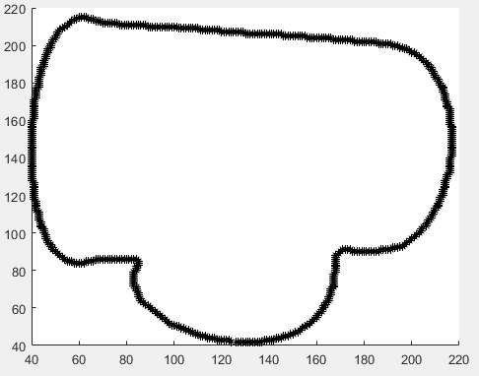

Step1 map image of Cup4 Step2 Main counter of cup

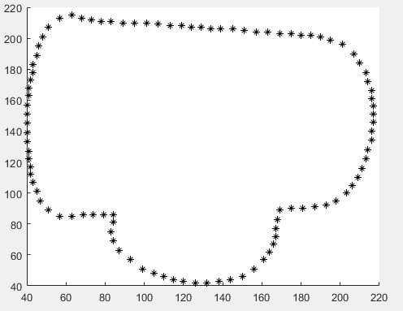 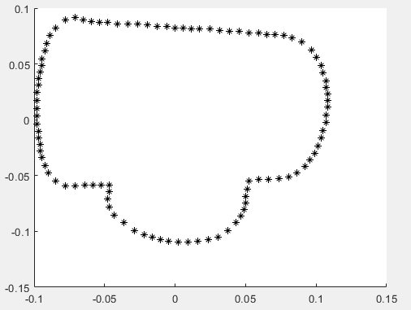

Step2 100 pseudo-landmarks of cup4 Step pre-shape of cup4

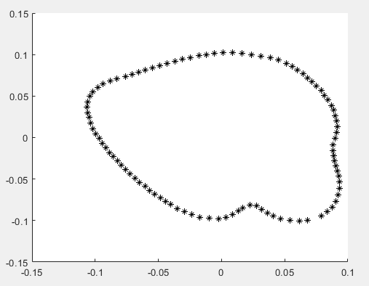

Step4 mean shape of cup except 4

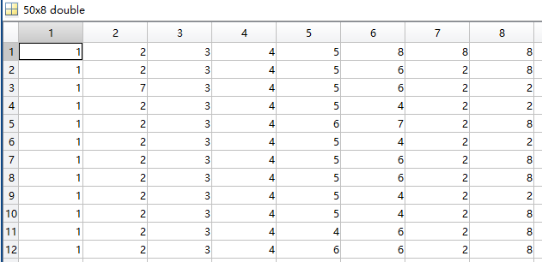

Step5 and 6 part of the result matrix.

u=0.7125.

v=0.1294.

## Discussion:

1. In my opinion, the main issue of this project is the extraction of landmarks.

I’m not an expert and I can’t give the correct anatomical landmarks. And this work will take long time even if only 80 images.

I try to use Mathematical landmarks like using SURF FAST Harris. But I can not make them to get more landmarks. But I need to let the number of landmark is the same of each image.

Finally, I have to to use pseudo-landmark. I only use the main contour because I think it is enough after seeing the result. Most of the cups are classified to cups. It is complex to consider the secondary contour of cups, maybe need to set a ratio to distribute the 100 landmarks.

1. My getnextpoint function may be a trick. I use some properties of my contour image. Fortunately, it works for all 80 images. If there is a special images after canny, my function will need change.
2. I make an assumption that there is no same set of test sample in the 50 times “rand”.
3. ‘The result shows that, the u is between 0.7~0.75. v is around 0.12. But it hardly can classify tomatoes to tomatoes. Always to apples. The reason I think is that under this direction, tomato and apple are much similar in shape. We should use some other information to take apart them, may be color or texture.

Some mistakes also happen between cow, horse and dog. They both have 4 legs. Their shape are similar.